WELCOME TO NEXUS PLACE

We hope you enjoy your stay and wish you luck with your studies.

This document contains the answers to most questions.
We encourage you to familiarise yourself with its content and refer to it as necessary.

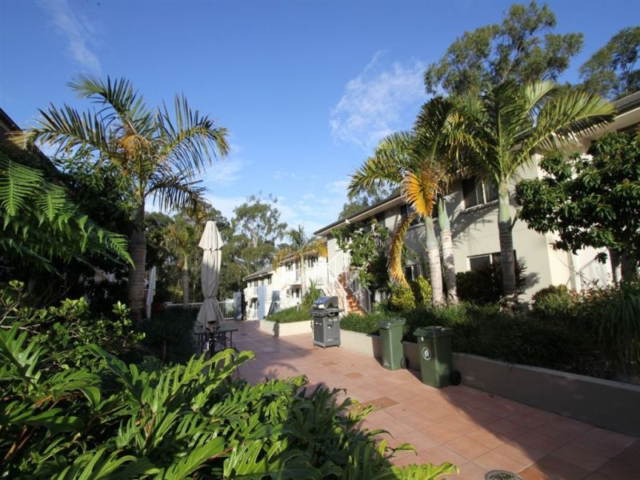

HOUSE RULES

Noise
All residents are entitled to relative peace and quiet in their individual rooms so they can study at any time. Excessive noise can interfere with residents’ ability to sleep, study or otherwise enjoy their living environment. Therefore there is to be no excessive noise audible in the courtyard after 10p.m. Sunday to Thursday and after 12 midnight on Fridays and Saturdays. It is a good idea to close front doors and windows in the evenings to help reduce the noise level in the courtyard.

Behaviour
Residents and their guests are expected to conduct themselves in a courteous and considerate manner within the complex.

Visitors
Visitors are welcome at Nexus Place. However residents should not invite more than 1 or 2 visitors at any one time as the facilities at Nexus Place are predominately for use by residents. Residents are responsible for the behaviour of their guests and are liable for any damage caused by their guests. Nexus Place is privately owned and operated and the management reserves the right of entry. Unwanted visitors or trespassers should be reported to the management as soon as possible.

Overnight Visitors
Occasional overnight visitors are welcome at Nexus Place. However these visitors must be registered at the office – via email. It is also a requirement that the other residents of that unit have given their consent. Residents should restrict themselves to one overnight visitor per week. Under special circumstances, residents would be allowed to have a visitor stay for more than 1 night (but less than 5nights) at a charge of $25 per night. Authorisation of special overnight visitors is essential. Residents who accommodate unauthorised visitors may be issued with a Notice to Remedy a Breach. Unplanned overnight visitors should be registered as soon as possible the following day. Living areas are not to be use for extra bed.
Failure to do this will incur a breach of tenancy agreement and possible termination of the agreement.

Social Gatherings
Social gatherings of Nexus Place residents are welcomed. The common areas – BBQ, games room and swimming pool all lend themselves to social interaction, however it is expected that residents clean up the area they have been using, respect the noise curfew and refrain from eating or drinking inside the pool enclosure. For the safety of all, the common areas of Nexus Place are GLASS FREE.
Nexus Place is not an appropriate venue for parties (e.g 18th and 21st birthday celebrations.)

Bicycles, Skateboards, Roller Blades, Scooters etc
For the safety of all and the protection of tenant cars, bicycles, skateboards, roller blades and scooters should not be used within the complex. Tenant bicycles should be locked into the stands provided in the garage area. Bicycles should never be taken into units. Please do not bring bicycles in through the pedestrian gate (motorized/bikes).
A Scooter or a motorbike if park in the basement must sign a separate agreement with the management and the charges is $5per week per motorbike/scooter. No car batteries are to be
Charged in the unit at any times.

Smoking
Smoking is not permitted at any time, in any room or enclosed area at Nexus Place – including the laundry and games room. Additional costs will be incurred where units are smoke damaged or malodorous. Cigarette butts should be disposed of in the ashtrays provided around the complex. Please do not throw cigarette butts on the ground or in the garden.

Alcohol
The management does not limit the use of alcohol at Nexus Place however residents are encouraged to use alcohol responsibly and in accordance with current liquor laws. Please respect the GLASS FREE rule in the common areas.

Candles and Incense
Because of the risk of fire and damage to surfaces, the burning of candles, incense and oils is prohibited anywhere in the Nexus complex. (Birthday candles on a cake are an exception to this rule).

Firearms, ammunition and illegal substances
Under no circumstances are residents to have in their possession at Nexus Place any firearms, ammunition, fireworks, hunting knives or other weapons (even with appropriate permits). Substances prohibited by law are also banned at Nexus Place. Disregard of this house rule would be considered a serious breach and will result in the immediate termination of the tenancy agreement and or a police action.

Pets
Residents are permitted to keep pet fish. Other animals including birds and reptiles are not permitted.

Posters
Posters and prints may be fixed to internal walls using non staining putty e.g. blu-tac .Please do not use staples, pins, nails, screws, sticky tape or double sided mounting tape to attach posters and prints. These items may cause permanent damage which would have to be repaired at the resident’s expense.

Clothes drying
The body corporate bylaws dictate that no clothing, washing etc is to be visible from any other unit so please do not hang towels etc over balcony rails. Clothes airers are for INDOOR use. (Mops and buckets should not be left outside units)

Smoke Alarms
The smoke alarms are hard-wired to the electricity supply and also have a back up 9v battery. When the battery is almost flat the alarm will start to beep. Please inform the management so that a replacement battery can be inserted.
If these alarms sound in a non-threatening situation (e.g. burnt toast) open all windows & doors and turn on the ceiling fans. These alarms have a clear plastic mute button that will temporarily stop the sound, but they cannot be turned off. They will also stop automatically when the smoke levels are reduced. Please do not remove the smoke alarms from the ceiling – they are there for your protection. Each bedroom also has a stand-alone smoke alarm – notify management when a new battery is required.
Thermal sensors have also been fitted in each lounge room. These have 2 red lights and no battery. The thermal sensors are connected directly to the fire brigade, therefore any interference with these units could result in a charge for a ‘false alarm’ call out, $1500 fine at tenant's cost. No candles at all times even during power outage.

Access to the Complex
Tenants should carry their keys with them at all times. Please do not jam or wedge open security doors or gates to prevent them from closing properly. Access to Nexus Place is through the pedestrian gate or garage ONLY, please do not climb or jump over any fence, gate or wall.
The intercom system at the pedestrian gate enables tenants to open the gate remotely from their unit. For the safety of all please do not open the gate before confirming the identity of the person entering.
Should you require management to unlock your unit or room for you, other than in office hours 9am to 5pm, there will be a charge of $30. Should you need to contact the management out of office hour, weekends or public holoday to gain access to the complex / your unit or your room a charge of $100 will apply.
All units must be locked when residents are not at home (even if they are still within the Nexus Place complex).

Swimming Pool
The hours of use are between 7.00 am and 10.00 pm Sunday to Thursday and between 7.00 am and 12 midnight Friday and Saturday. Residents should refrain from diving. Smoking, eating and drinking in the pool enclosure is not permitted. No glass bottles in the pool area at
any times.

Games Room / Ping Pong Table / BBQ
These amenities are provided FREE for the use of all Nexus Place residents. Please ensure they are used appropriately. It is expected that residents using these facilities will clean up before leaving the area. Smoking in the games room is not permitted.

Cleaning and Carpet Care
Residents are responsible for cleaning and maintaining their bedrooms and ensuites as well as the common area, its furnishings and contents. Please do not clean any surfaces with metal scourers or abrasive cleaners, we suggest you only use nylon scourers and liquid cleaners. Carpets should be vacuumed weekly, and vacuum cleaners need to be emptied weekly. If something is spilled on the carpet, pour water onto it immediately and sponge it up with a towel. Never rub the carpet or apply anything other than water. If in doubt please contact the office ASAP. Carpet is to be professionally clean every 12 months.

Floor and wall tiles are best cleaned with white vinegar and water. There are several spray- on shower cleaners which are easily used. Ensuites should be cleaned weekly to avoid damage from mould build –up.

Ovens need to be cleaned regularly. To clean an oven effectively a commercial oven cleaner should be used in accordance with the manufacturers instructions. (Rubber gloves are recommended as most oven cleaners are caustic). Regular use of oven bags for roasting meats will greatly reduce the need to clean the oven. This will also help reduce the incidence of activating the smoke alarms when cooking.
Room cleaning is mandatory and must organized by the site manager when you are vacating . Total fee is $200 (plus GST) which must be paid by the tenants.

Rubbish and Recycling
All food and general non-recyclable rubbish should be placed into a plastic bag and tied securely before being placed in the ‘skip’ bin at the front of the complex. Recyclable materials should be placed in the designated ‘skip’ bin also at the front of the complex.( For further information about recycling see the back of this handbook.)
Bags of rubbish are not to be left on landings, stairwells or outside units. Please do not use the bins in the laundry, games room, near the BBQ and table settings for unit waste.

Insurance
The management, body corporate and individual unit owners DO NOT carry any insurance covering tenants’ property or vehicles. It is highly recommended that all tenants consider their own personal insurance.

Replacement keys
Management has duplicate keys for each room. Should you misplace your keys, this set is available until such time as the original set is found. Replacement keys are charged as follows: Room and garage keys $90 each
Letterbox keys $30 each

Office Hours
Office hours are posted on the office door. Please respect the managers’ right to privacy when the closed sign is displayed. In the event of an emergency, phone the number displayed on the office door to contact the managers.

Vehicles
Unauthorised vehicles are not to be parked in the garage at any time and may be towed away at the owner’s expense. Mechanical repairs are not permitted in the garage and spare parts should be stored in your vehicle, not on the garage floor. Residents may wash their vehicles onsite, however they will need to make arrangements to borrow hoses etc from the management. Residents should also consider current water restrictions before washing their vehicle.

Shopping Trolleys
Management does not encourage tenants to transport groceries from the nearby supermarket to Nexus Place in trolleys belonging to that supermarket. (It may even be an offence to remove the trolleys from the shopping complex). Tenants who bring shopping trolleys back to Nexus Place are required to return them TO THE SHOPPING CENTRE immediately they have emptied them, please do not leave them parked outside the complex.

Postal delivery
Australia post delivers mail to the letterboxes in the front fence of the complex, each week day morning (excluding public holidays). Residents should state their unit number in their address. Parcels delivered to the office will be redirected to the correct unit as soon as practical after delivery. Mail incorrectly posted to your letterbox should be either placed in the manager’s letterbox (number 8) or delivered to the office for redirection – please do not keep unclaimed mail in your units. Also tenants should be aware that it is an offence to open mail addressed to someone else.

Telephone connections
There is a telephone line in the common room as well as each of the three bedrooms in each unit at Nexus Place. The connection cost and ongoing expenses are the responsibility of the tenant. If you wish to have the telephone connected in your room / unit you should contact Telstra on 132200. Please ensure you include your unit number in your address.

Internet Connection
Nexus Place has its own broadband WIFI network which is accessible to tenats. Internet access via this network is UNLIMITED for 1 device only, included in the rental price. You will be issued with a user name and password on arrival.

Electricity and Gas Hot Water
Access to electricity & Gas Hot Water is included in the rent payable under the terms of the Rooming Accommodation Agreement.
Please remember to turn off lights, TVs, fans and stereos before leaving the room / unit. Leaky taps should be reported to management (via email) as soon as possible to minimise the excess water use.

Emergency Evacuation
The evacuation procedure is displayed on the inside of the front door of each unit. You should read it and become familiar with the procedure. There are heat sensors in every unit which are ‘back to base’ wired. This means if they are activated the Fire Brigade are automatically alerted and will arrive.
The emergency assembly area is on Currumburra Road at the main entrance. If the alarm sounds YOU MUST LEAVE YOUR ROOM IMMEDIATELY and go to the assembly area as quickly as possible. Always check that the other 2 rooms in your unit are vacated and close the front door when you leave. The Fire Brigade recovers the costs of deliberate or malicious false alarm call outs and these costs are charged to the tenant/s responsible.

Repairs and Maintenance Requests
All repairs and maintenance are arranged through the management. Residents are not authorised to call repair services (unless there is an emergency situation and the management is not contactable). Please make your requests for repairs and maintenance via email to lifeisgood@nexusplace.com

Transport Options
The local SURFSIDE bus service operates between Ashmore City and Griffith University.
Services arealso available between Ashmore Plaza and Australia Fair (Southport) and PacificFair (Broadbeach).For full list of service details log on to www.surfside.com.au

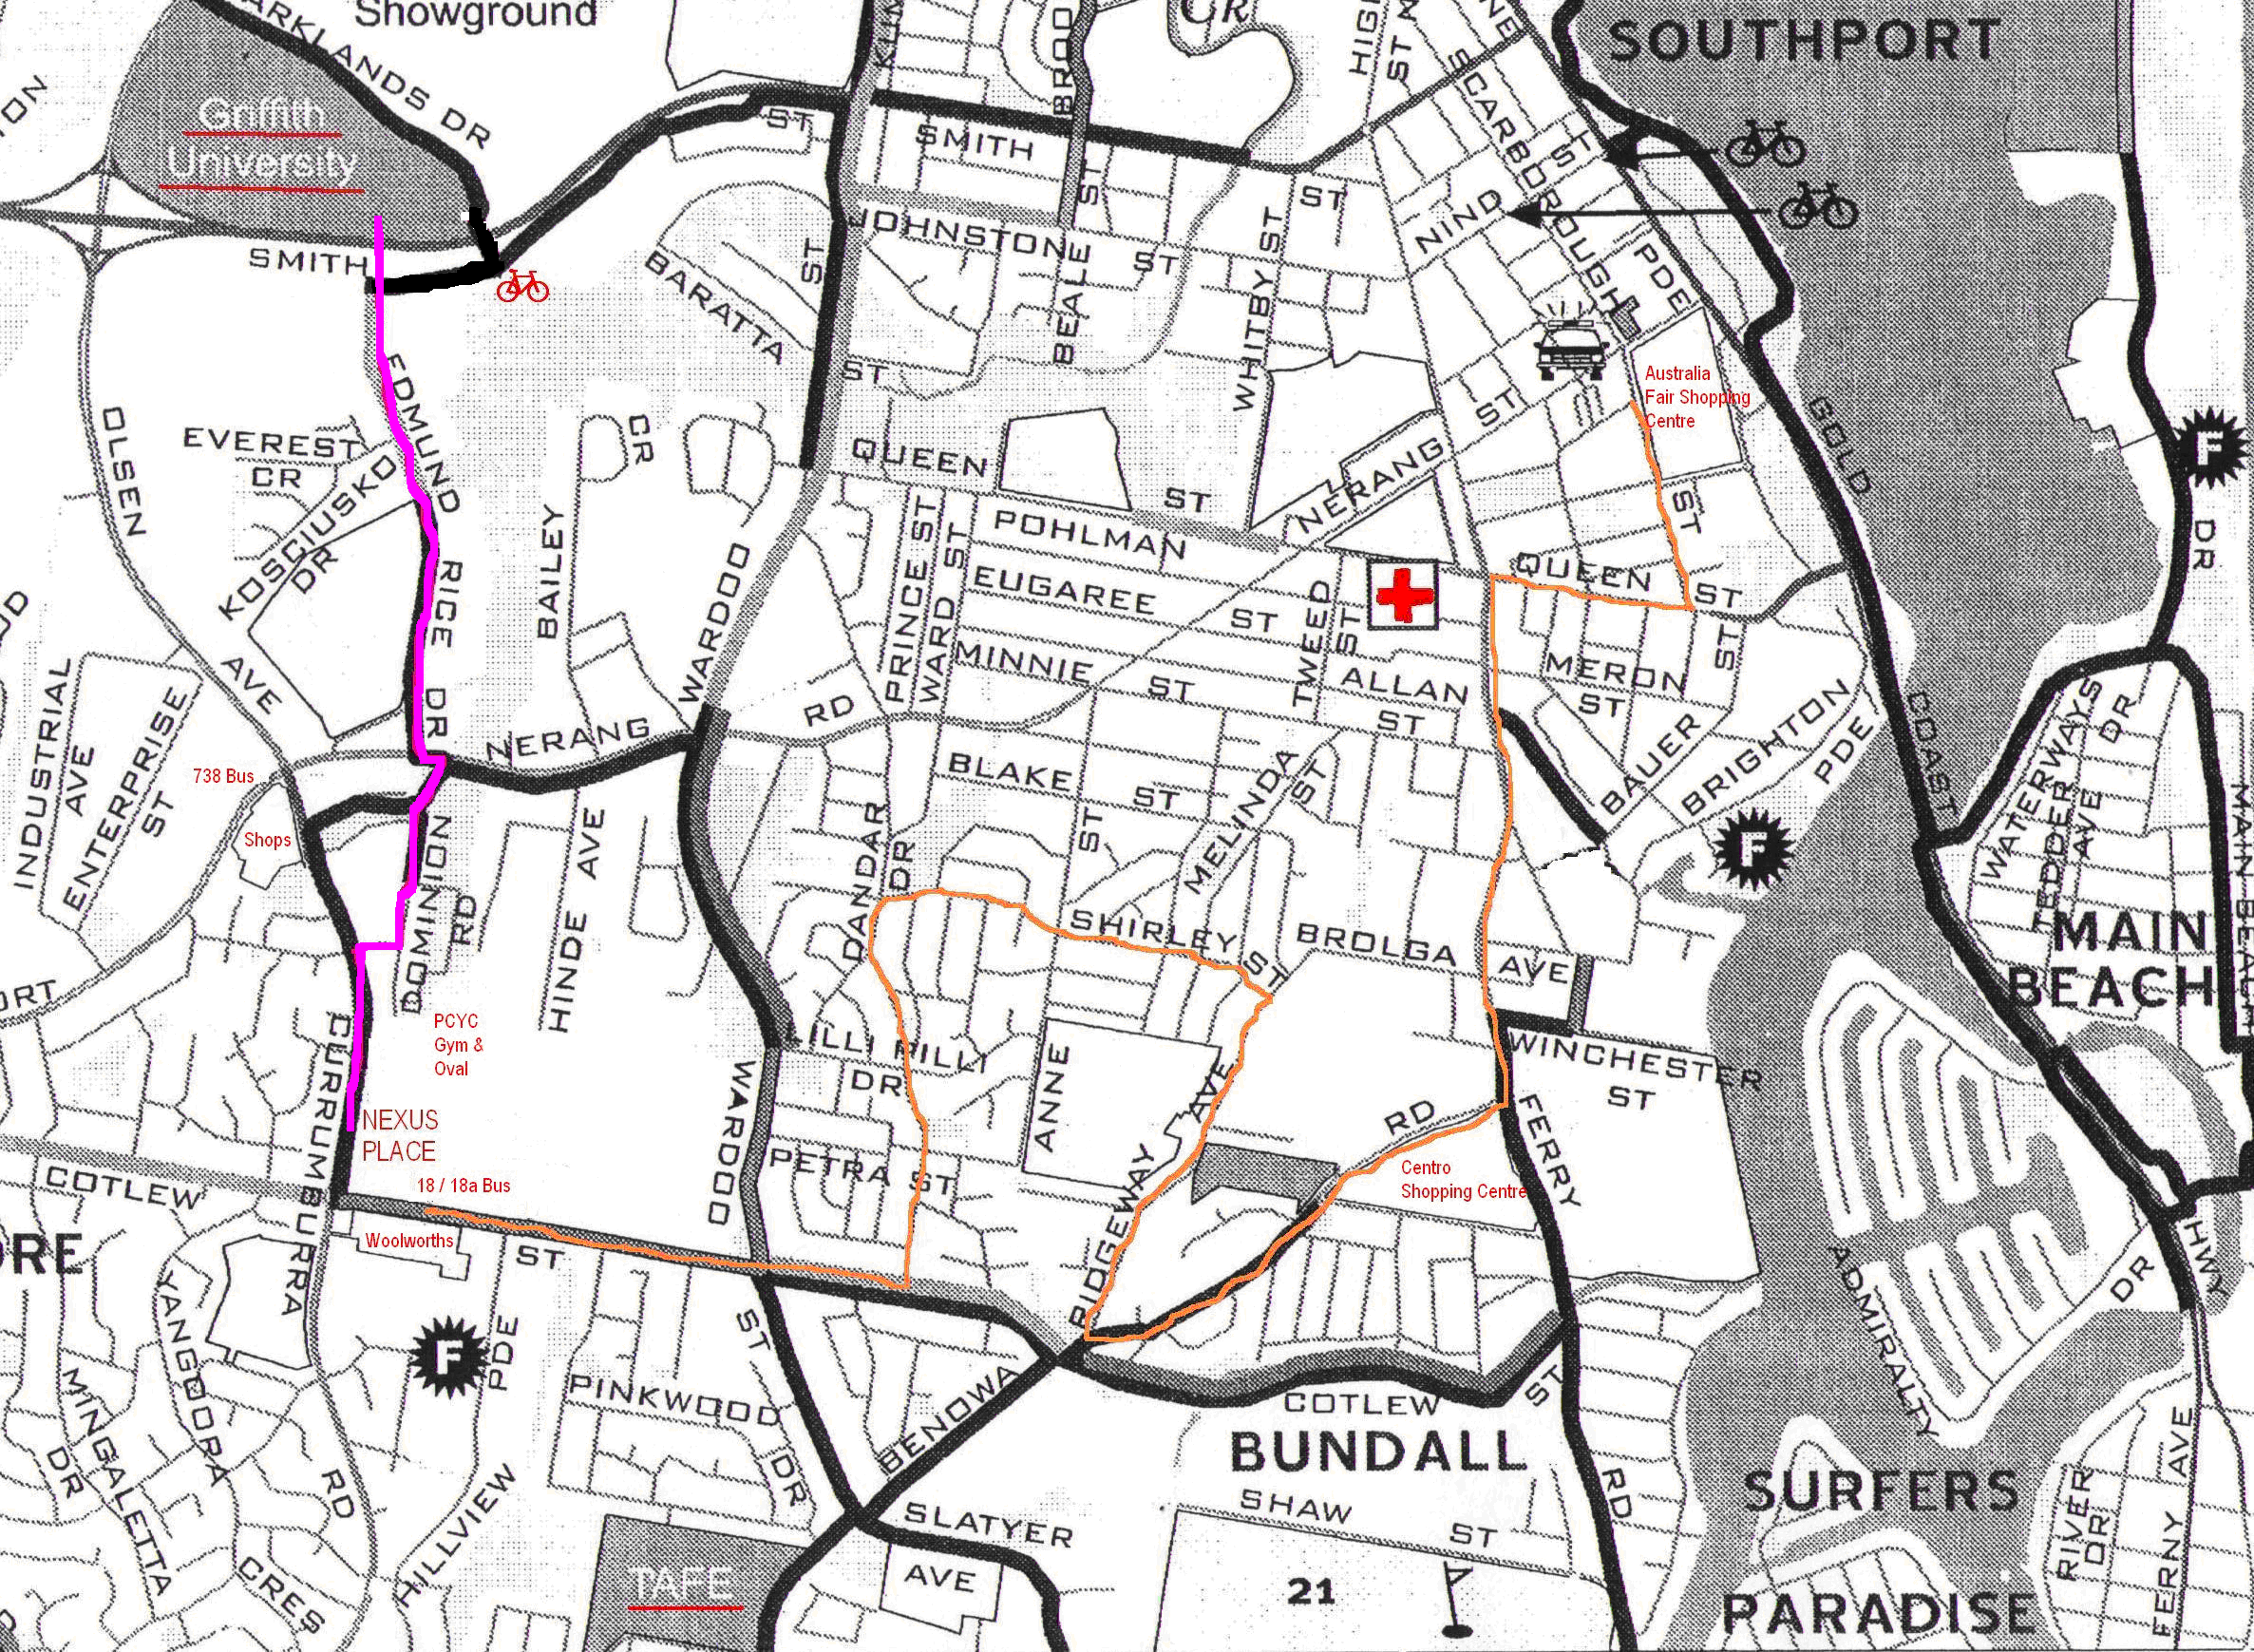
Termination of Lease
If you have not notified the management that you intend to renew your lease, you will be issued a 'Notice To Leave'. This means you must vacate your room by 10am on the last day of your lease. You should refer to the “Departing Tenant Schedule” in this handbook.

You will be required to leave your room, bathroom and the common area clean (including walls, floors, ensuite, oven, cooktop, fridge and microwave and cupboards etc). You are also required to launder all linen supplied (pillow protector, mattress protector and bedspread) and ensure the bedroom carpet is professionally shampooed.
*You are NOT required to clean windows, venetians, shampoo lounge suites or shampoo common area mats.

A cleaning fee of $185 including GST (Carpet cleaning included in the cleaning cost) applies to each lease. Tenants are required to remove all rubbish to the bins and ensure all kitchen items are cleaned and stowed in the cupboards for an exit inspection, all other cleaning costs are covered by this fee.

Residents are responsible for the cost of repairs to or replacement of any items damaged / missing, as identified by an exit inspection (not including fair wear and tear) plus any outstanding rent or car parking fees before the bond is released. Once signed by both parties you can take the form to any Queensland Post Office to be refunded, alternatively you can nominate a bank account to have the Bond directly deposited.

Should you decide to break your contract and leave before the date nominated in the ‘Rooming Accommodation Agreement’, you are required, under Queensland Law, to continue paying all rent until a replacement tenant takes up residence. You are required to pay all costs relating to the reletting of your room (e.g. the letting fee which is equal to one week’s rent + G.S.T.). It is a good idea to talk to the management if you are considering breaking your lease to ensure you understand your rights and responsibilities. You cannot sub-lease your room yourself. We will work with you to find another tenant if required.

SOME USEFUL NUMBERS

NEXUS MANAGERS 55279492 MEDCALL (AFTER HOURS DOCTORS) 55311224
0405046620

NEXUS FAX 55279478 STUDENT GUILD (GRIFFITH UNI) 55528724

TAXI 131008 CAMPUS COMPUTERS 55528510

ASHMORE HAIR DESIGN 55395415

Simple Recycling Rules - It is important that only the items listed into the recycling bin. Recycling is easy! - Please follow these simple recycling rules:
Only put in items from the kitchen, bathroom or laundry NOT the garage or garden shed
Put recyclables loosely in the bin NOT in plastic bags
Rinse containers
Make sure aerosol cans are empty
Only glass bottles and jars
Only glass bottles and jars can be recycled Please help the Gold Coast's recycling system by recycling only glass bottles and jars. No other 'glass' items are acceptable. Other types of vitreous materials (china, pottery, crystal, oven-proof dishes, lightbulbs, TV and computer screens, window and mirror glass) can't be mixed in with the packaging glass (bottles and jars) because they don't melt at the same temperature. One tiny chip of the wrong material can make a weakness in a recycled glass bottle and this is very dangerous once the bottle is filled and sold. The weakness could cause the recycled bottle to split or shatter when someone takes the lid off.
Don't use plastic bags Please don't wrap or bag recyclables. Just put them in the bin loose.
Be safe All recyclables are sorted by hand, so think safe - please, never put syringes in with your recycling.
Bottles and Jars Aluminium and seel cans Clean cardboard, newspaper, All household plastic bottles
Made only of glass and aerosols magazines and cartons and containers

Departing Tenant Schedule
- Arrange a suitable time for an inspection of your unit.
- Redirect your mail at the post office.
- Disconnect the telephone.
- Pay outstanding accounts for rent
- Cancel automatic rent payments at your bank.
You are also required to launder all linen supplied (pillow protector, mattress protector and bedspread) and ensure the bedroom carpet is professionally shampooed.
- *You are NOT required to clean windows, venetians, shampoo lounge suites or shampoo common area mats.

A cleaning fee of $200 plus GST applies to each lease. Tenants are required to remove all rubbish to the bins and ensure all kitchen items are cleaned and stowed in the cupboards to all for an exit inspection.

- Don’t throw out good food, organise to give it to a fellow resident who is staying. Unwanted clothing / bedding can be donated to Life Line etc via the charity bins in the car park of the Ashmore Tavern.
- Remove any oil spills from the garage where your car was parked.
- Return all keys, leave ADSL cables in desk drawer and handbook in loungeroom.
- Bond refunds can be collected from any Queensland Post Office. It takes
about 25 minutes to process.

